Canberra Fires
06-02-2020 07:00
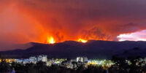
On Friday, authorities in Australia´s capital city, Canberra, declared a state of emergency because of very serious fire conditions that are a threat to people´s lives and houses.
It is the first state of emergency for the Canberra territory since January 2003, when the fires killed four people.
There has been warning that strong winds and rising temperatures could increase the danger of fire in Canberra and its surroundings. Canberra´s chief minister said that the fires can become unpredictable and difficult to control. According to media, 8% of the Australian Capital Territory is now consumed by fires, and residents are advised to wait for potential evacuation orders.

